**ITIL v4 Guiding Principles**

ITIL (Information Technology Infrastructure Library) v4 provides a framework for managing IT services. Its guiding principles are recommendations that help organizations adopt and adapt ITIL best practices in a flexible, balanced, and integrated way. The **seven ITIL v4 guiding principles** are:

**ITIL v4 Guiding Principles 🌟**

1. **Focus on Value** 🎯: Ensure everything is done with the customer and stakeholder value in mind.
   * **Example**: Prioritize fixing a broken feature on a customer-facing application because it directly affects user satisfaction.
2. **Start Where You Are** 🏁: Assess the current situation and use existing resources and capabilities.
   * **Example**: If you have existing automation tools, build on them instead of starting from scratch.
3. **Progress Iteratively with Feedback** 🔄: Break down work into smaller pieces and gather feedback for improvement.
   * **Example**: Release features incrementally and improve them based on user feedback.
4. **Collaborate and Promote Visibility** 🤝: Work together across teams and departments, ensuring everyone is aligned.
   * **Example**: Development and operations teams collaborate closely for smooth software deployment.
5. **Think and Work Holistically** 🌍: Consider the end-to-end impact of decisions, ensuring all services, processes, and departments work together.
   * **Example**: A change in IT infrastructure impacts customer service, so both teams should be involved in planning.
6. **Keep It Simple and Practical** ⚙️: Focus on simplicity and avoid overengineering processes.
   * **Example**: Streamline a ticketing system so users can easily raise issues without confusion.
7. **Optimize and Automate** 🤖: Continuously improve services and automate routine tasks.
   * **Example**: Automate system monitoring to reduce workload and allow staff to focus on strategic tasks.

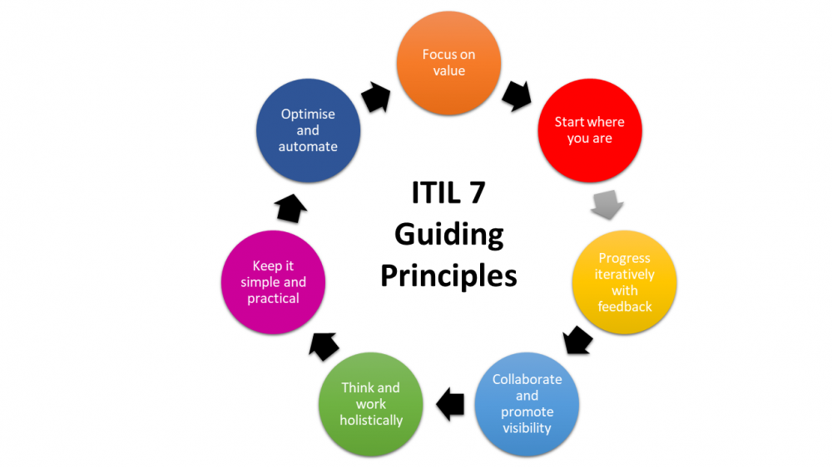

**Service Value Management with Example 💡**

Service Value Management (SVM) focuses on creating and managing value through services delivered to customers.

**SVM includes:**

* **Service Value System (SVS)** 🔄: A system that co-creates value with all stakeholders.
* **Service Value Chain** 🔗: Activities that transform inputs into outputs, delivering value.
* **Governance** 🛡️: Aligns all activities with the organization’s strategy and objectives.
* **Continual Improvement** 📈: Constant review and enhancement of services for greater value.

**Example of SVM:** A cloud-based application helps businesses manage their inventories:

1. **Value Creation** 💼: Regular feature updates based on customer feedback.
2. **Service Delivery** 🚚: Regular updates and performance fixes for a smooth user experience.
3. **Performance Tracking** 📊: Monitoring uptime and user satisfaction metrics to ensure the service delivers value.
4. **Continual Improvement** 🔧: Optimizing the infrastructure to improve system speed and customer satisfaction.

**IT Architecture 🏗️**

IT architecture refers to the design and structure of IT systems, aligning them with business goals.

**Key Components of IT Architecture:**

1. **Infrastructure Architecture** 🖥️: Hardware and software that support operations (e.g., servers, storage, networks).
2. **Application Architecture** 📱: The structure of software applications to ensure scalability and flexibility.
3. **Data Architecture** 📚: Organizing and protecting data to support decision-making.
4. **Security Architecture** 🔒: Ensuring systems are secure and comply with regulations.
5. **Integration Architecture** 🔌: Enabling seamless communication between systems and services.

**Example of IT Architecture:** For global expansion, an organization might implement:

* **Cloud Infrastructure** ☁️ to scale as needed.
* **Distributed Application Architecture** 🌍 for resilience and availability across regions.
* **Unified Communication Systems** 📞 for seamless voice, email, and messaging integration.
* **Data Architecture** 🧠 to support real-time analytics globally.
* **Security Architecture** 🔐 to comply with regulations and secure customer data.

**SDLC (Software Development Life Cycle) 🛠️**

The **Software Development Life Cycle (SDLC)** is a structured process used for developing software applications. It outlines the phases of software development, from initial planning through to maintenance, ensuring the project is completed efficiently, within budget, and meets user requirements.

**Phases of SDLC:**

1. **Requirement Gathering and Analysis** 📋
   * In this phase, the project's goals, user needs, and system requirements are gathered.
   * **Example**: A company collects input from users and stakeholders to define the core features needed in a mobile app, like payment integration, notifications, etc.
2. **System Design** 🖊️
   * The system’s architecture and design are created, specifying the system's components and their interactions.
   * **Example**: Designing the database schema for the mobile app, including tables for users, transactions, and notifications.
3. **Implementation (Coding)** 💻
   * Developers start coding according to the design specifications.
   * **Example**: Developers write code for the payment integration and notification system for the app.
4. **Testing** 🧪
   * The software is tested to find and fix bugs or issues before it is released.
   * **Example**: The app is tested to ensure payments are processed correctly, and notifications are sent as expected.
5. **Deployment** 🚀
   * The software is deployed to the production environment for use by end-users.
   * **Example**: The app is launched on the App Store and Google Play for users to download.
6. **Maintenance** 🔧
   * Post-launch support is provided to fix any issues and ensure the system continues to meet user needs.
   * **Example**: After launch, bugs are fixed, and new features (such as adding multi-currency support) are introduced.

**SOLID Principles ⚙️**

The **SOLID** principles are a set of five design principles intended to make software design more understandable, flexible, and maintainable. They are often applied in object-oriented programming (OOP).

**1. Single Responsibility Principle (SRP) 📚**

* **Definition**: A class should have only one reason to change, meaning it should only have one job or responsibility.
* **Example**: In an e-commerce application, the OrderProcessing class should only handle the processing of orders, not the logic for emailing customers or managing payments. These should be separate classes.

**2. Open/Closed Principle (OCP) 🚪**

* **Definition**: Software entities (classes, modules, functions, etc.) should be open for extension but closed for modification.
* **Example**: If you need to add a new type of payment method, you should extend the payment processing system by adding a new class instead of modifying the existing ones.

**3. Liskov Substitution Principle (LSP) 🔄**

* **Definition**: Objects of a superclass should be replaceable with objects of a subclass without affecting the functionality of the program.
* **Example**: If you have a Vehicle class and a Car subclass, you should be able to use Car objects anywhere you use Vehicle objects without breaking the system.

**4. Interface Segregation Principle (ISP) 📜**

* **Definition**: Clients should not be forced to depend on interfaces they do not use. It’s better to have multiple small, client-specific interfaces rather than a large, general-purpose one.
* **Example**: Instead of having a Machine interface with methods like Print, Scan, and Fax, create separate interfaces like Printable, Scannable, and Faxable for specific functionalities.

**5. Dependency Inversion Principle (DIP) 🔄**

* **Definition**: High-level modules should not depend on low-level modules. Both should depend on abstractions. Additionally, abstractions should not depend on details. Details should depend on abstractions.
* **Example**: Instead of the OrderProcessing class directly depending on a specific payment service (e.g., CreditCardPayment), it should depend on an abstraction (e.g., PaymentService interface), allowing different payment methods to be easily swapped.

**Summary with Example:**

Imagine building an **online bookstore app**:

1. **SDLC**:
   * **Requirement Gathering**: You gather features like book search, customer reviews, and order history.
   * **Design**: Design the database for books, users, and orders.
   * **Implementation**: Developers implement the catalog browsing and purchase functionality.
   * **Testing**: The app is tested to ensure users can browse, buy books, and leave reviews.
   * **Deployment**: The app is published on the app store.
   * **Maintenance**: The app gets bug fixes, and new features like wishlist functionality are added.
2. **SOLID**:
   * **SRP**: The Book class is responsible for book details, and the Order class handles order management.
   * **OCP**: When you add a new payment method (e.g., PayPal), you create a new class extending PaymentMethod rather than modifying the existing payment code.
   * **LSP**: You can replace the CreditCardPayment with a PaypalPayment in the order processing without breaking the system.
   * **ISP**: The PaymentProcessor interface only has payment-related methods, avoiding unnecessary methods like ShippingAddress or OrderHistory.
   * **DIP**: OrderProcessor depends on an abstraction (PaymentService), not a concrete implementation (e.g., CreditCardPayment).